**Experiment 2: Visualization of COVID‑19 Data**

**Introduction:**  
This experiment demonstrates how to visualize COVID‑19 trends in the United States using Python’s Pandas, Matplotlib, and Seaborn libraries

**Data Preparation**

1. **Load the Dataset and Convert Date Format:**
   * The dataset is loaded using pd.read_csv().
   * The ‘Date’ column is converted to a datetime format for proper plotting.
2. **Handle Missing Data:**
   * Missing values in the ‘Recovered’ column are filled with 0.
3. **Filter and Aggregate Data for the US:**
   * Data is filtered where Country/Region == 'US'.
   * Data is grouped by date to aggregate Confirmed, Deaths, and Recovered cases.

**Code:**

import pandas as pd

import matplotlib.pyplot as plt

import seaborn as sns

# Load the COVID‑19 dataset

file_path = "/content/time-series-19-covid-combined.csv" # Update with your file path if needed

data = pd.read_csv(file_path)

# Convert the 'Date' column to datetime format

data['Date'] = pd.to_datetime(data['Date'])

# Fill missing values in 'Recovered' with 0

data['Recovered'].fillna(0, inplace=True)

# Filter the dataset for the United States

country_data = data[data['Country/Region'] == 'US']

# Aggregate data by date (in case there are province/state-level details)

country_data = country_data.groupby('Date')[['Confirmed', 'Deaths', 'Recovered']].sum().reset_index()

**COVID‑19 Confirmed Cases Over Time (US):**

plt.figure(figsize=(12, 6))

sns.lineplot(x='Date', y='Confirmed', data=country_data, label='Confirmed Cases', color='blue')

plt.title('COVID‑19 Confirmed Cases Over Time - US')

plt.xlabel('Date')

plt.ylabel('Number of Cases')

plt.xticks(rotation=45)

plt.grid(True)

plt.show()

**Explanation:**This line plot visualizes the trend of confirmed COVID‑19 cases in the US. The x‑axis represents the date, while the y‑axis shows the cumulative number of confirmed cases

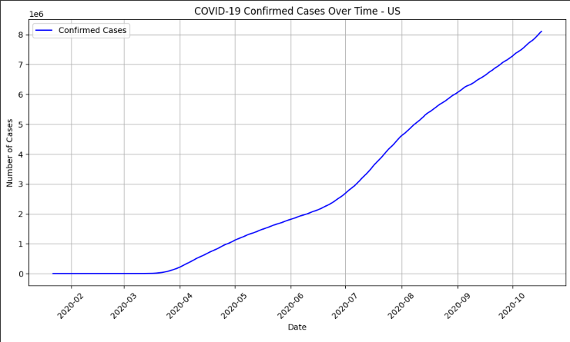

**COVID‑19 Deaths Over Time (US):**

plt.figure(figsize=(12, 6))

sns.lineplot(x='Date', y='Deaths', data=country_data, label='Deaths',

color='red')

plt.title('COVID‑19 Deaths Over Time - US')

plt.xlabel('Date')

plt.ylabel('Number of Deaths')

plt.xticks(rotation=45)

plt.grid(True)

plt.show()

**Explanation:**This plot displays the trend of COVID‑19 related deaths in the US. The x‑axis shows the date, and the y‑axis shows the cumulative number of deaths.

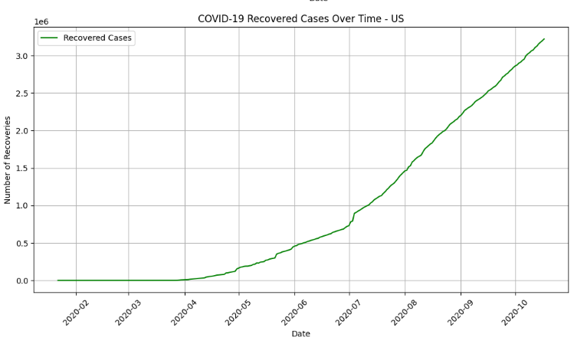

**COVID‑19 Recovered Cases Over Time (US):**

plt.figure(figsize=(12, 6))

sns.lineplot(x='Date', y='Recovered', data=country_data, label='Recovered Cases', color='green')

plt.title('COVID‑19 Recovered Cases Over Time - US')

plt.xlabel('Date')

plt.ylabel('Number of Recoveries')

plt.xticks(rotation=45)

plt.grid(True)

plt.show()

**Explanation:**This line plot shows the progression of recovered COVID‑19 cases in the US. The x‑axis represents the date, and the y‑axis shows the cumulative number of recoveries.

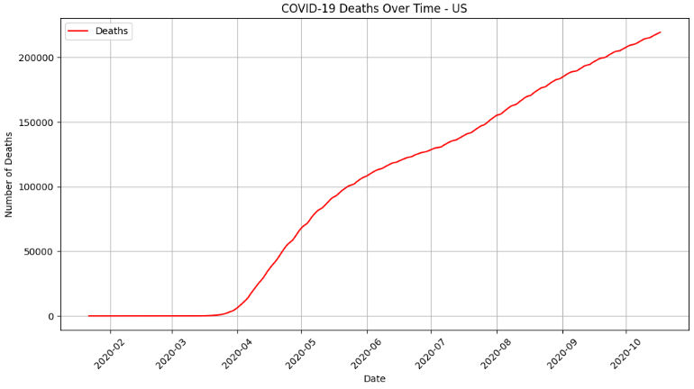

**Combined Plot: Confirmed, Deaths, and Recovered Cases Over Time (US):**

plt.figure(figsize=(12, 6))

sns.lineplot(x='Date', y='Confirmed', data=country_data, label='Confirmed

Cases', color='blue')

sns.lineplot(x='Date', y='Deaths', data=country_data, label='Deaths',

color='red')

sns.lineplot(x='Date', y='Recovered', data=country_data, label='Recovered Cases', color='green')

plt.title('COVID‑19 Confirmed, Deaths, and Recovered Cases Over Time - US')

plt.xlabel('Date')

plt.ylabel('Number of Cases')

plt.xticks(rotation=45)

plt.grid(True)

plt.legend()

plt.

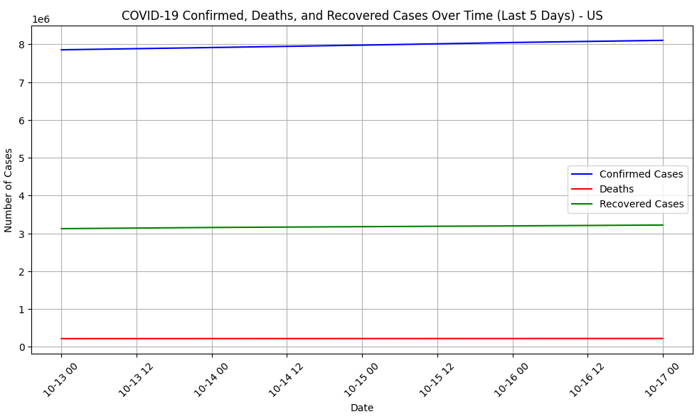

**Explanation:**This combined plot provides an overview of the COVID‑19 situation in the US by illustrating the trends of confirmed cases, deaths, and recoveries over time on the same graph.

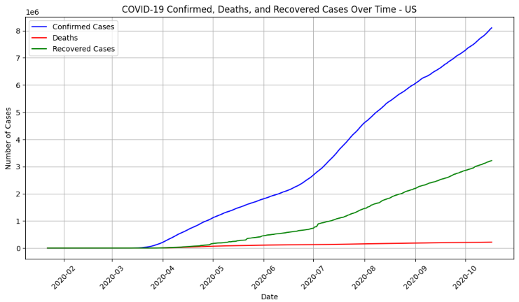

#### **Result:**

Thus the visualization techniques in Time Series Analysis and Forecasting has been studied successfully